

Dr. Amber, Roach inc.

2023-06-29

Dr. Roach

637 Smith Port Suite 687, Joneschester, UT 09910

Phone: 2621400876

Fax: 3777531195

**Re:** Jacqueline, Gallagher

**PHN:** 2675998934

**Birthdate:** 01-Jul-1981

**Address:** 3753 Brooke Isle Apt. 605, East Karenland, AS 38930

**Patient number:** 8596843632

To Whom It May Concern:

This is a medical letter to state the above patient is pregnant with expected delivery date of 20-Aug-2025. Hoping this information is satisfactory for your requirements.

Thank you.

Sincerely,

Dr. Amber, Roach

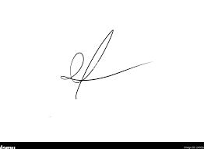

FRCS© NCMP

Clinical Assistant Professor, UBC

Department of Obstetrics and Gynecology SMH